

***An internship report submitted by***

# MANOSHIKA CATHERINE S J (URK21CS1196) MEENALOSHINI C (URK21C02010)

***in partial fulfillment for the award of the degree of***

## **BACHELOR OF TECHNOLOGY**

***in***

**COMPUTER SCIENCE AND ENGINEERING**

***under the supervision of***

# Dr. T JEMIMA JEBASEELI, Associate Professor



**DIVISION OF COMPUTER SCIENCE AND ENGINEERING**

## KARUNYA INSTITUTE OF TECHNOLOGY AND SCIENCES

(Declared as Deemed to be University under Sec-3 of the UGC Act, 1956)

**Karunya Nagar, Coimbatore - 641 114. INDIA**



**DIVISION OF COMPUTER SCIENCE AND ENGINEERING**

**BONAFIDE CERTIFICATE**

This is to certify that the report entitled, “**Accident Locations on Indian Roads**” is a bonafide record of Internship work done at **Intel Unnati Training Program** during the academic year 2022-2023 by

# MANOSHIKA CATHERINE S J (URK21CS1196) MEENALOSHINI C (URK21C02010)

in partial fulfillment of the requirements for the award of the degree of Bachelor of Technology in Computer Science and Engineering of Karunya Institute of Technology and Sciences.



**Guide Signature** Dr. T Jemima Jebaseeli Associate Professor

# ACKNOWLEDGEMENT

First and foremost, I praise and thank ALMIGTHY GOD whose blessings have bestowed in me the will power and confidence to carry out my internship.

I am grateful to our beloved founders **Late. Dr. D.G.S. Dhinakaran C.A.I.I.B, Ph.D** and **Dr. Paul Dhinakaran M.B.A, Ph.D**, for their love and always remembering us in their prayers.

We extend our tanks to **Dr. Prince Arulraj M.E., Ph.D.,** our honorable vice chancellor, **Dr. E. J. James, Ph.D.,** and **Dr. Ridling Margaret Waller Ph.D.,** our honorable Pro-Vice Chancellor(s) and **Dr. R. Elijah Blessing Ph.D.,** our respected Registrar for giving me this opportunity to do the internship.

I would like to thank **Dr. Ciza Thomas M.E., Ph.D.,** Dean, School of Engineering and Technology for her direction and invaluable support to complete the same.

I would like to place my heart-felt thanks and gratitude to **Dr. J. Immanuel Johnraja M.E., Ph.D.,** Head of the Department, Division of Computer Science and Engineering for his encouragement and guidance.

I feel it a pleasure to be indebted to Dr. T. Jemima Jebaseeli, Associate Professor, Division of CSE & Mr. Abhishek Nandy, Intel Industrial Mentor for their invaluable support, advice and encouragement.

I would also like to thank all my friends and my parents who have prayed and helped me during the Internship.

ACCIDENT LOCATION ON INDIAN ROADS

**INTEL UNNATI TRAINING PROGRAM**

SUMMER – 2023

TEAM NAME : INTELLIGENCESTER

**Author:**

[Manoshika Catherine S](https://www.researchgate.net/profile/Pachaivannan-Partheeban?enrichId=rgreq-076e785ad2e45487355a42adc87754a7-XXX&enrichSource=Y292ZXJQYWdlOzIyNDEyNzc2ODtBUzo1NTI2MDk5MzkwMzgyMDhAMTUwODc2Mzg4NDgzMQ%3D%3D&el=1_x_5&_esc=publicationCoverPdf) J

B.Tech Computer Science Engineer

[Karunya Institute Of Technology](https://www.researchgate.net/institution/Chennai_Institute_Of_Technology?enrichId=rgreq-076e785ad2e45487355a42adc87754a7-XXX&enrichSource=Y292ZXJQYWdlOzIyNDEyNzc2ODtBUzo1NTI2MDk5MzkwMzgyMDhAMTUwODc2Mzg4NDgzMQ%3D%3D&el=1_x_6&_esc=publicationCoverPdf) and Sciences Contact Info : [manoshika@karunya.edu.in](mailto:manoshika@karunya.edu.in)



Meenaloshini C

B.Tech Computer Engineer

[Karunya Institute Of Technology](https://www.researchgate.net/institution/Chennai_Institute_Of_Technology?enrichId=rgreq-076e785ad2e45487355a42adc87754a7-XXX&enrichSource=Y292ZXJQYWdlOzIyNDEyNzc2ODtBUzo1NTI2MDk5MzkwMzgyMDhAMTUwODc2Mzg4NDgzMQ%3D%3D&el=1_x_6&_esc=publicationCoverPdf) and Sciences Contact Info : [meenaloshinic@karunya.edu.in](mailto:meenaloshinic@karunya.edu.in)

**Project Details :**

TEAM NAME : INTELLIGENCESTER

PROJECT TITLE : ACCIDENT LOCATION ON INDIAN ROADS TEAM LEADER : MANOSHIKA CATHERINE S J

TOOL USED : ARC GIS

WEBSITE LINK : [Accident Locations on Indian Roads (arcgis.com)](https://www.arcgis.com/apps/instant/imageryviewer/index.html?appid=4fe10f64eeae409ab83407dec9f1d5ba&locale=en-us)

APP LINK : [Install Imagery Map Viewer | AppHost](https://appho.st/d/0pmEtoAF)

|  |  |
| --- | --- |
| Project Status Report | Overall Status: Successfully  Completed |

Project Name: Accident Location on Indian Roads

Date _ From : 1 /June/2023 - To : 8 /July / 2023

|  |  |
| --- | --- |
| Status Code Legend |  |
| * To get a Clear Idea of the Project | * To develop a Website to plot the Accident Locations in a Map |
| * To Analyse the Data of the Accident Prone Locations in the Chennai City. | * To develop a Android Application to Access the Website |

|  |  |
| --- | --- |
| The project is **Successfully Completed** the week of 01/06/2023 – 08/07/2023,  with following work done : | * Analyzing the Data of Accident Prone locations in Chennai City. * Developing a Website to showcase the Accident Prone Areas with their Ward no. * Developing a Android App to view the Website. * Creating a Project Report. |
| Data Analysis : 01/06/2023 – 08/06/2023 | * The Chennai City was Selected to do the Project. * The list of Accident Prone Areas in Chennai City was Analysed based on the Number of Accidents in Chennai in the last 5 years. * The Ward No’s of that Particular zones were Identified. * The Pincode of the Particular Zones were Identified. * The Hospitals that are nearby to the Accident Prone Areas were Identified to be helpful in case of an Emergency was Identified. * These Data was depicted and was created as a table in an SVG File file:///C:/Desktop/Data/Data%20Analysis%20-%20Accident%20Locations.svg |
| Mapping :  11/06/2023 – 17/06/2023 | * The Arc Gis Tool was Identified and selected to create the Project.   The Greater Chennai Ward Boundaries Map was Identified from the World Atlas map in the Arc Gis Stimulator Tool .   * The Ward No’s were Identified in the Map to plot the Ward no’s that we have Analysed. * The Accident Prone Places with their Ward no’s in their respective places was Plotted on the Map. * Using the Properties option in the Map , the Data with their Ward no was Feeded. * A Button was Created using the Properties option to display the details that were feeded when the Button is Onclicked . |
| Website Devlopment : 19/06/2023 – 24/06/2023 | * The Map that was Created in the Arc Gis Simulator Tool was Imported into the Arc Gis Wepage Developing Software. * A Website was developed to showcase the Map. https://[www.arcgis.com/apps/instant/imageryviewer/index.html?appid=4fe10f64eeae409ab83](http://www.arcgis.com/apps/instant/imageryviewer/index.html?appid=4fe10f64eeae409ab83)   407dec9f1d5ba&locale=en-us |
| App Devlopment : 25/06/2023 – 27/06/2023 | * The App Geyster Software was selected to develop An App. * An Mobile Application was Developed to access the Website. * The App was Hosted in the AppHost Platform , APP NAME: IMAGERY MAP VIEWER. * <https://appho.st/d/0pmEtoAF> - Link to Download the App |

|  |  |  |  |
| --- | --- | --- | --- |
|  | | | |
|  | Publishing the App : 28/06/2023 | * The App was Tested and was Checked Thoroughly. * The App was Published and was Installed by the Users . * The users started using this Mobile Application without any Interruptions |  |
| Reviewing the App : 28/06/2023 – Until date | * The Review for the App was Taken from the Users * There was a Positive Review from the Users . * The App was Reviewed by the Industrial Mentor and had an Positive Feedback. |
| Report Generation : 02/07/2023 | * An Project Report was Generated by the Head of the Team . * The Project was collected based on the work that we had accomplished while doing this Project. |
| Contact Information : | | |
| PROJECT HEAD ;  PROJECT TEAM NAME : INTELLIGENCESTER  TEAM LEAD BY : MANOSHIKA CATHERINE S J ( B.Tech Computer Science Engineer ) EMAIL ID : [manoshika@karunya.edu.in](mailto:manoshika@karunya.edu.in) | | | |

# Accident Location on Indian Roads – Chennai City

T

##### *Abstract*— Road accidents are one of the most important problems being faced by modern

**societies. Apart from the humanitarian aspect of reducing road deaths and injuries in developing countries, a strong case can be made for reducing road crash deaths on economic grounds alone, as they consume massive financial resources that the countries can ill afford to lose. The deaths of persons and serious economic loss caused by road accident demand a continuous attention in accordance withthe spectacular growth in road transportation. It is now realised that better and more efficient techniques of accident information management are required. GIS provides a single framework within which both spatial and attribute information can bestored and effectively displayed. This paper explains the development of a GIS using the Map Info and ArcVIEW GIS toaccess accident in Chennai. Also deals with the forecasting of the road accident and based on the datacollected from various accident studies. The outcome of the study is highly useful for the retrieval of road accidents in Chennai. An Android App is developed to view the Accident Locations in the Chennai City .**

INTRODUCTION

Traffic on the Indian City roads has increased tremendouslydue to the increasing rate of Urbanisation.

Globalisation of the Indian economy and the improvement in economic status ofthe people has also induced greater impact on thetransportation system. Increasing inadequacy of publictransport, rising rate of vehicle ownership and migration ofpeople to urban fringes have led to extensive use of privatemodes and closing the road network. The traffic movements in city roads have been compounded by frequent interruptions,resulting in drastic reduction in speed, leading to congestionand accidents. Road accidents cause injury, death, loss ofproperty and damages to vehicles. All these involve amonetary loss to the economy. When roads are improved, road accident rate comes down. This results in quantifiable benefitsto the economy (Kadiali, 1990). Though the overall death rate has declined and expectation of life has gone up, the death risk on roads has considerably increased. Apart from thehumanitarian aspect of reducing road deaths and injuries in developing countries, a strong case can be made for reducingroad crash deaths on economic grounds alone, as they consume massive financial resources that the countries can illafford to lose. That said it must of course be borne in mind that in developing and emerging nations, road safety is but one ofthe many problems demanding its share of funding and otherresources. Even within the boundaries of the transport and highway sector, hard decisions have to be taken on the resources that a country can devote to road safety. In order toassist in this decision-making process it is essential that method be devised to determine the cost of road crashes and the value of preventing them.

Collection of Data Resources

#### Accident Prone zones in Chennai City

Road traffic injuries are the eighth leading cause of death globally. In its study highlighting the larger share of Low and Middle Income Countries in road accident fatalities, the World Bank underscores a distinct co-relation between socio-economic status and road use patterns in low and middle income countries such as India. The report states that daily wage workers and those employed as casual labourers in informal activities are more prone to be defined as vulnerable as compared to workers engaged in regular activities. It is often the poor, especially male road-users of working age that constitute the vulnerable road users (VRU) in India where VRUs share road space with other less vulnerable users with their income level having a direct bearing on the mode of transportation used and resultant risk faced by them on that account. Numerous factors can be attributed to be the causative factors of road accidents and can be broadly classified into road environment factors, human factors and vehicular factors .

**DATA ANALYSIS**

Data Analysis - Accident Locations.svg - This svg file has been created to show the Accident Locations in the Chennai City with its Ward no to allocate in the Map and the Famous Hospitals that are nearer to the Accident Prone Locations in the Chennai City , based on the data that has been analyzed

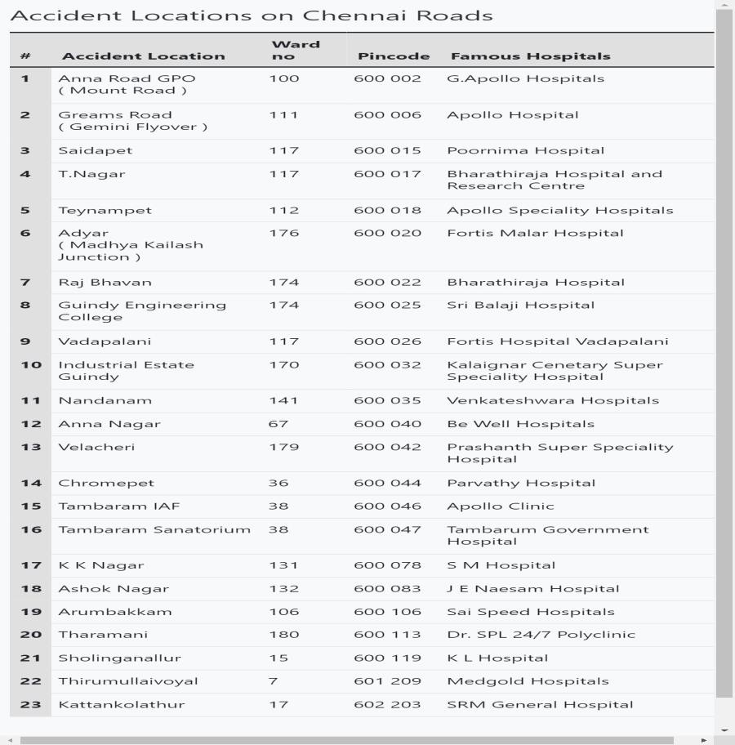

## Plotting the Accident Zones in the Map

#### ARC GIS Tool

ArcGIS Experience Builder empowers you to easily build the exact web apps to Create a compelling, immersive web experience for your audience with flexible design and page options that allow you to unify apps, pages, and both 2D and 3D data. Exercise creative control on how your web app looks on mobile, tablet, and desktop to ensure that your audience gets information on any device when they need it. Build custom widgets, themes, and actions to further extend your web app. This ARC GIS Tool is used to stimulate the collectes data in a Map view . The Greater Chennai Ward Boundaries map is used to Plot the Accident Areas .

Description

The city ward boundaries represent the administrative and electoral boundary areas of the city. It plays a great role in planning of the city, for each council of the municipal corporation.

This web layer represents ward boundaries of [Greater Chennai Corporation](https://chennaicorporation.gov.in/gcc/) along with following attributes:

* Town Name
* Town Census Code 2011
* Town LGD Code
* Ward LGD Code
* Ward LGD Name
* Ward Name (Source)
* Ward Code (Source)
* State

**Data Development Approach:**

1. **Map Search** - Search for authentic/relevant ward boundary map, ([Map Source](https://maps-chennai.com/chennai-ward-map))
2. **LGD Mapping** - Match the ward details with [Local Govt. Directory,](https://lgdirectory.gov.in/)
3. **Data Development** - Convert the digital map to GIS format with [ESRI platform,](https://www.esri.com/en-us/arcgis/products/index)
4. **QA/QC** - Quality check of the developed boundaries,
5. **Sharing** - Publish to [Living Atlas of the World.](https://livingatlas.arcgis.com/en/browse/#d%3D2)

<https://www.arcgis.com/apps/mapviewer/index.html?webmap=11126cb413b9466fb3d3bea38c7ba805>

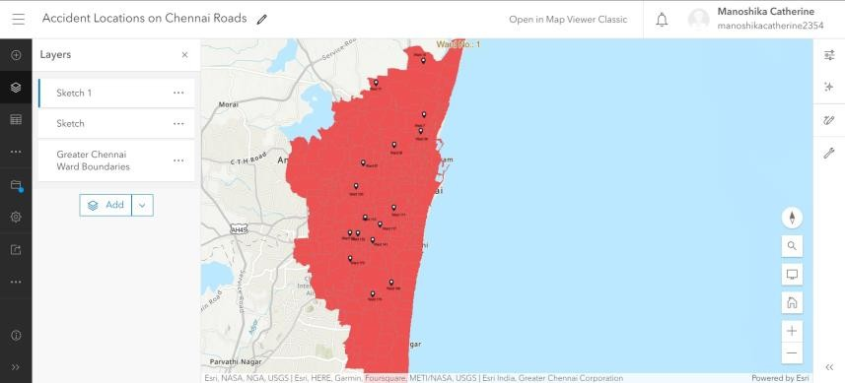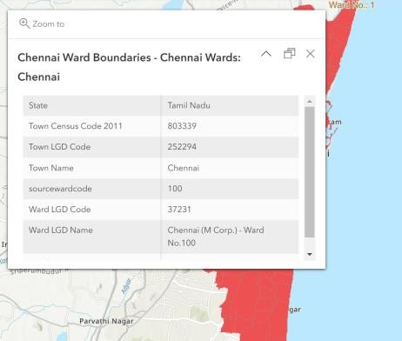

When an Accident plotted area is clicked it Displays the Ward details of that particular area

[Accident Locations on Indian Roads (arcgis.com)](https://www.arcgis.com/apps/instant/imageryviewer/index.html?appid=4fe10f64eeae409ab83407dec9f1d5ba&locale=en-us)

## App Development

#### Imagery Map Viewer App

Web application development allows web-based projects to function and behave like mobile applications. Web applications prioritize responsive interactions with users while still delivering content through a network and the internet. An Android Application is developed using the website that has been created using the Arc Gis Tool. The Android Application is easier to use than the Website.

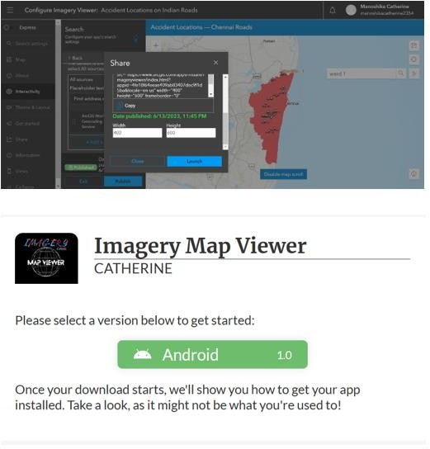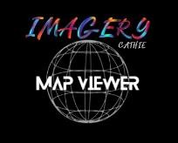*App Designing in Configure Imagery Viewer App Downloading QR code*

[Install Imagery Map Viewer | AppHost](https://appho.st/d/0pmEtoAF) *App Logo*

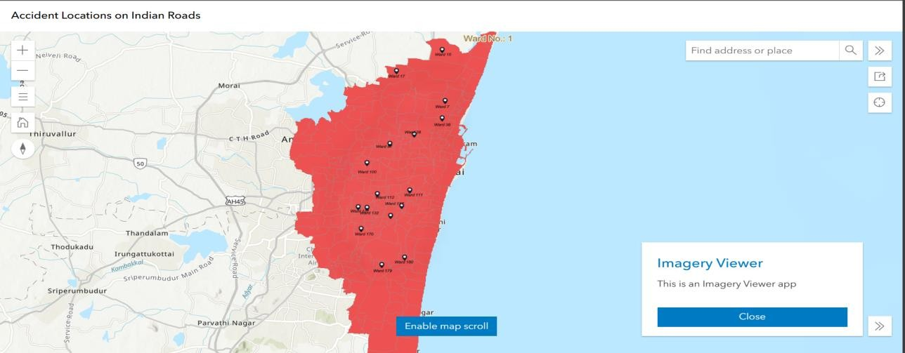

*Imagery Map Viewer App*

This Imagery Map Viewer App allows you to access the accident points and showcases their ward number details , it allows us to zoom in or zoom out an area , it enables us to scroll the Map , It allows us to search a particular area in that Map . It showcases the Accident Points in Chennai City. These Accident locations can be taken into special consideration by the Tamilnadu Ministry to avoid the accidents in that area. The Accident Locations on Chennai City is spotted Succesfully .